Company/ Client: NCOC N. V | Project: ESKENE WEST KARABATAN |  |  | Location: Sulphur Plant Tranche.02
Tag No:  A1-550-VA-250 | Component examined | Material | SA 516 GR.70 | Work order: 27885954
Procedure No:  QP-11-UTT-Q01 REV 00 | Component examined | Día X Nominal Thickness | Ø 2050 mm | Probe Details
Manufacturing Code/Acceptance Standard:  As per client specification | Component examined | Operating Temp | Ambient | Probe | OLYMPUS  D790  S/N: 1058416
Method: Contact | Reference Calibration Block Details | Block | Step wedge | Angle | 0º
Method: Contact | Reference Calibration Block Details | Range | (6.25 – 25) mm | Frequency | 5 MHz
Equipment: Olympus 38DLP S/N:171421601 | Reference Calibration Block Details | Accuracy | 0.025 mm | size | 11 mm
Equipment: Olympus 38DLP S/N:171421601 | Reference Calibration Block Details | Temperature | Ambient | Crystal | Dual
Surface condition: Coated | Correction factors | N/A |  | Reference sensitivity | 2nd backwall reflection to 80% FSH
Couplant: Gel | Correction factors |  |  | Scan Sensitivity | Reference dB
Job Description:
- UT has been carried out on selected location and spot reading taken. More info in section Details and Results.
- Inspection done on Painted Surface.
- Inspection done on External surface of the vessel.

Legend:
FSH: Full Screen Height, N/A: Not Applicable

DETAILS AND RESULTS
Observed Thickness:

S/NO | Item description | DIA(Ø) | Nominal WT | East  (3 o’clock) | West | North | South | Top | Bottom | Centre
1 | Section 1 (Header) | - | 12.0 | 12.4 | 12.1 | - | - | 12.3 | 12.2 | 13.2
2 | Section 2 (Shell) | - | 25.0 | 26.2 | 26.7 | - | - | 26.5 | 26.9 | -
3 | Section 3 (Shell) | - | 14.0 | 15.7 | 15.9 | - | - | 15.2 | 15.8 | -
4 | Section 4 (Header) | - | 12.0 | 12.6 | 12.0 | - | - | 12.0 | 12.4 | 12.6
5 | Section 5 (Boot Shell) | - | 14.0 | 15.6 | 15.6 | 15.7 | 15.2 | - | - | -
6 | Section 6 (Header) | - | 12.0 | 12.1 | 12.7 | 12.7 | 12.9 | - | - | 11.7
7 | Nozzle N2 | 6” | 14.27 | 15.3 | 15.9 | 15.7 | 15.4 | - | - | -
8 | Nozzle N3 | 18” | 14.0 | 14.5 | 15.1 | 14.9 | 14.7 | - | - | -
9 | Nozzle N5 | 2” | 13.46 | 14.3 | 14.0 | 14.0 | 14.8 | - | - | -
10 | Nozzle N6 | 2” | 11.07 | 12.1 | 11.5 | 11.5 | 11.7 | - | - | -
11 | Nozzle N7 | 2” | 11.07 | 11.8 | 11.7 | 11.4 | 11.5 | - | - | -
12 | Manway M1 | 24” | 14.0 | 15.4 | 15.6 | 15.2 | 14.8 | - | - | -

A1-550-VA-250

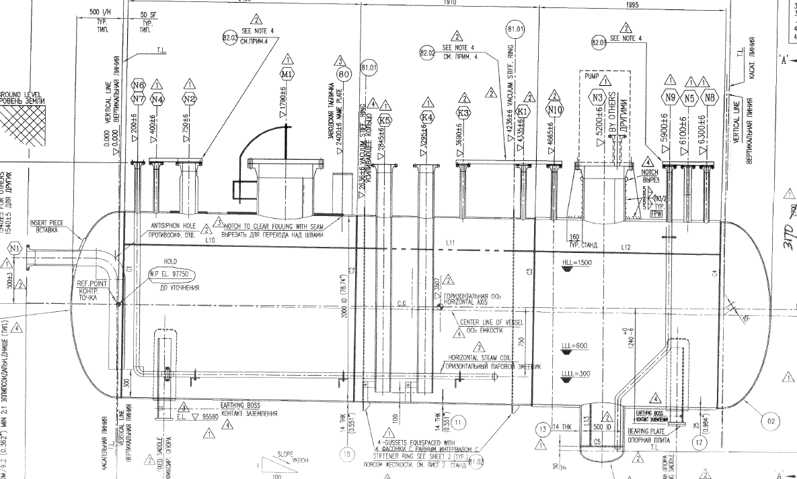

Sec 1
Sec 2
Sec 3
Sec 4
Sec 5
Sec 6
North
side
Southside
N6/ N7
N2
M1
N3
N5

Note: All readings mentioned above are with painting.

DETAILS AND RESULTS
A1-550-VA-250

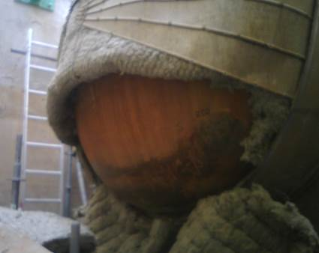
Section 1

Section 2
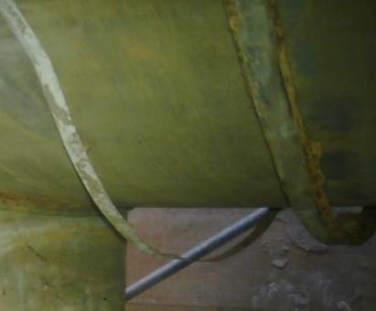
Section 3

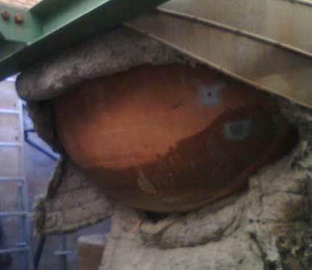
Section 4
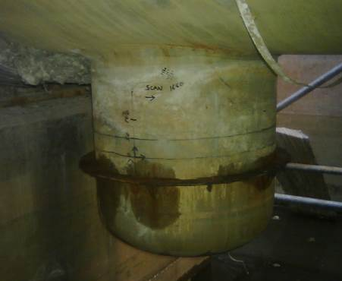
Section 6
Section 5
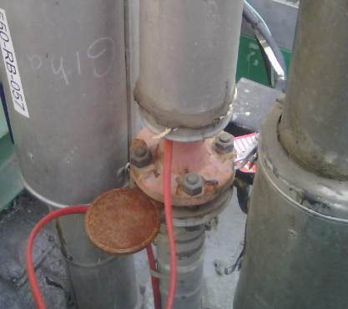
Nozzle N5
UTT Area

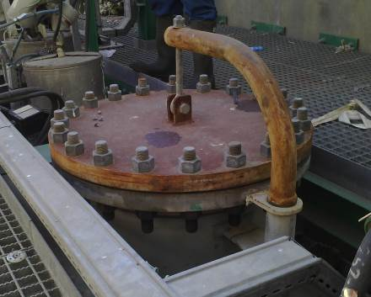
Nozzle M1
UTT Area
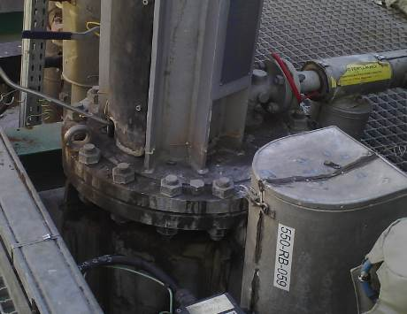
Nozzle N3
UTT Area
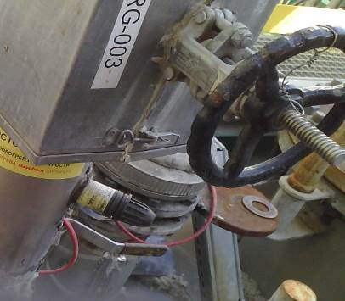
Nozzle N2
UTT Area

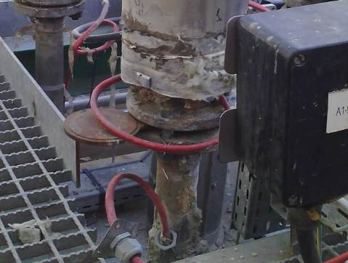
Nozzle N7
UTT Area
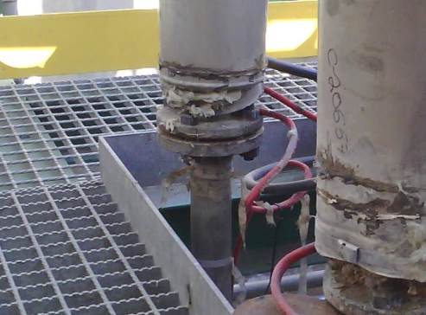
Nozzle N6
UTT Area

DETAILS AND RESULTS
Thickness Observed on Raster scanning:
A1-550-VA-250

S/NO | Item description | Minimum Thickness(mm) | Min | Max
1 | Boot head | 12.0 | 10.8 | 11.5
2 | Vessel head 1 | 12.0 | 12.4 | 13.5
3 | Vessel head 2 | 12.0 | 12.0 | 13.5

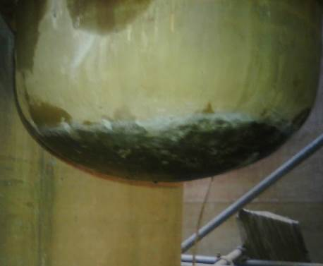
UT Scanning area
1
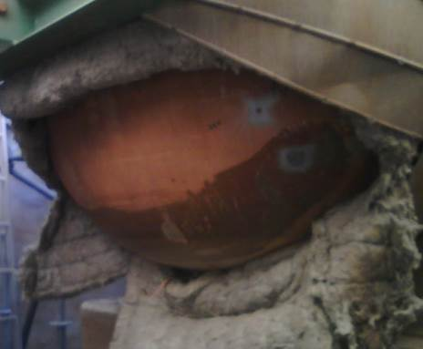
UT Scanning area
2
North
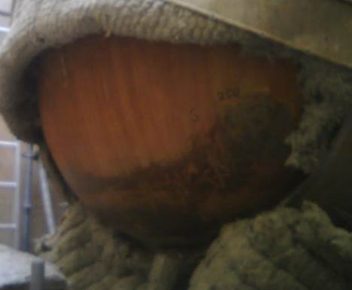
South
UT Scanning area
3

Note:
All readings taken on the painted surface except boot.
Raster scanning has been done on Boot and bottom section of vessel head 1 & 2.

